Classification of SMILES Strings as Toxic or Non-Toxic Based on the Presence of Toxicophores

Project Report submitted by
SAMRUDDI NG (NNM22IS136)
SAI ABHIJT VAICHAL (NNM22IS134)
RIDHI S K (NNM22IS127)
MAITHILI KP (NNM22IS087)
Students of
Department of Information Science and Engineering
Under the Guidance of
Dr.Balaji S
Manipal Institute of Technology
In partial fulfillment of the requirements for the successful completion of internship
at Manipal Institute of Technology, Manipal
Department of Information Science and Engineering
NMAMIT Institute of Technology
(Affiliated to Manipal Institute of Technology)

July 2025

ABSTRACT

In cheminformatics, toxicophores refer to specific structural features or chemical subgroups within a molecule that are associated with undesirable biological effects. Toxicophores are detected based on studies made on how molecules structure affects its biological activity.
Over the years, scientists have found that certain chemical groups which show up repeatedly in compounds known to cause harmful effects. Because of this, detecting these groups early in a molecule's design or evaluation helps researchers filter out potentially dangerous compounds.
As part of our academic internship, we worked on a project focused on toxicity prediction using cheminformatics and machine learning. The goal of the project was to develop a system that could classify chemical compounds as toxic or non-toxic based on the presence of toxicophores.
Our project followed a structured approach. We began by studying various fingerprinting and feature extraction techniques which includes MACCs, Morgan Fingerprints, Atom Pair Fingerprints, Topological Fingerprints and deep learning model GNN (Graph Neural Networks). Next we focused on data acquisition. Initially, we attempted to fetch compound data from the ZINC20 API, but due to usage limits IP blocks so we switched to using a VPN and then also explored open sources like Hugging Face.
Once data collection was complete, we used RDkit platform, which provides various cheminformatics tools to extract toxicophore-related features from each compound. These features were then used to train and evaluate four machine learning models: Support Vector Machine (SVM), Random Forest, Logistic Regression, and XGBoost.
After training the models, we conducted a comparative evaluation of their performance using standard classification metrics such as accuracy, precision. This allowed us to assess how effectively each model could distinguish between toxic and non-toxic compounds based on the extracted features.Once the models were trained and evaluated, we used them to classify an unlabeled dataset consisting of chemical compounds with unknown toxicity status.

INTRODUCTION

The ability to predict the toxicity of chemical compounds is a vital part of modern drug discovery and chemical safety evaluation. Traditional laboratory testing for toxicity is expensive, time-consuming, and often unfeasible for large chemical libraries. As a result, computational approaches — particularly those involving cheminformatics and machine learning — have gained significant traction for early-stage toxicity screening.
One of the key concepts in this domain is that of toxicophores — specific substructures within molecules that are known to be associated with adverse biological effects. By identifying these structural patterns, researchers can flag potentially harmful compounds early in the development pipeline. Over time, extensive structure-activity relationship (SAR) studies have linked toxicophores like nitro groups, aromatic amines, epoxides, and halogenated phenols to various forms of toxicity.
In this project, we aimed to develop a system that leverages the presence of toxicophores in chemical structures to classify molecules as either toxic or non-toxic. The compounds were represented using SMILES (Simplified Molecular Input Line Entry System) strings, which were processed using RDKit, a cheminformatics toolkit, to extract structural features and detect toxicophores.
Our work involved studying several molecular fingerprinting techniques — including MACCS keys, Morgan fingerprints, Atom Pair fingerprints, and Topological fingerprints — to represent molecular structures in a format suitable for machine learning. We also explored the use of Graph Neural Networks (GNNs), which are particularly well-suited for learning directly from graph-based molecular structures.
After collecting molecular data from various sources, including the ZINC20 API and Hugging Face datasets, we trained four machine learning models: Support Vector Machine (SVM), Random Forest, Logistic Regression, and XGBoost. These models were evaluated using standard classification metrics to determine their effectiveness in predicting toxicity. Finally, we used the trained models to classify an unlabeled dataset of chemical compounds with unknown toxicity, demonstrating the real-world applicability of our approach.

MOTIVATION

Traditional toxicity testing is slow, costly, and relies heavily on laboratory experimentation.

Laboratory methods are resource-intensive and do not scale efficiently across large chemical libraries.

This project aims to provide a faster and more scalable solution using machine learning and cheminformatics.

Publicly available datasets and molecular representations such as SMILES and fingerprints are used to train predictive models.

The focus is on detecting toxicophores—molecular substructures associated with toxicity.

Recent advancements in machine learning, including the use of Morgan fingerprints and Graph Neural Networks (GNNs), enable more effective modeling of molecular data.

The ultimate objective is to automate toxicity prediction in a way that is scalable, cost-effective, and interpretable.

IMPLEMENTATION

Fingerprint Techniques in Toxicity Prediction and Selection of Morgan Fingerprints

The key to cheminformatics, paired with a cohort chemical structure, is accurately predicting chemical properties, including toxicity. Fingerprinting is an important method for translating molecular structure from formats that make this information human understandable to formats that make this information machine-readable to statistical and machine learning models. In the project, we discussed methodologically different fingerprinting methods that encode the molecular structure in unique ways on how these fingerprints were applicable.
1. MACCS Keys (Molecular Access System)
MACCS keys are among the most widely used structural fingerprints. They consist of a fixed-size bit vector (usually 166 bits), where each bit corresponds to the presence or absence of a specific chemical substructure or feature.
- Advantages:
  - Computationally efficient
  - Easy to interpret
  - Serves as a strong baseline for molecular classification
- Limitations:
  - Limited to a predefined set of substructures
  - May miss nuanced or novel toxicophoric features not covered by the fixed key list

2. Morgan Fingerprints (Extended-Connectivity Fingerprints / ECFP)
Morgan fingerprints, based on the extended-connectivity fingerprint algorithm, are circular fingerprints that encode atomic neighborhoods around each atom up to a defined radius. These are hashed into a fixed-length binary vector, effectively capturing local structural environments.
- Advantages:
  - Captures detailed, circular substructures crucial for toxicity prediction
  - Highly customizable (e.g., radius, bit vector size)
  - Ideal for identifying functional groups and toxicophores
  - Supported extensively by RDKit, facilitating seamless integration and scalability
- Limitations:
  - Slightly more computational cost compared to simpler fingerprints
  - Requires thoughtful parameter tuning to balance performance and dimensionality
3. Atom Pair Fingerprints
Atom pair fingerprints represent each molecule as a set of atom pairs, along with the number of bonds separating them. They provide information about long-range atomic interactions.
- Advantages:
  - Suitable for capturing distant dependencies within a molecule
  - Useful when spatial arrangement or bond distance is crucial
- Limitations:
  - Produces high-dimensional and sparse vectors
  - Can be less effective for compact datasets due to noise and sparsity
4. Topological Fingerprints
Topological fingerprints encode the paths or sequences of bonds between atoms, up to a certain path length. They emphasize the overall connectivity and topology of the molecule.
- Advantages:
  - Capture both local and global structural features
  - Provide a more holistic view of molecular connectivity
- Limitations:
  - High dimensionality
  - Potential redundancy and overfitting with smaller datasets

5. Graph Neural Networks (GNNs)
Unlike traditional fingerprints, GNNs learn from molecular graphs directly, where atoms are nodes and bonds are edges. They learn to extract patterns and embeddings that are not explicitly encoded by rule-based fingerprints.
- Advantages:
  - Learns complex, hierarchical patterns
  - Avoids reliance on predefined features
- Limitations:
  - Requires significantly more data and training time
  - Model interpretability is lower compared to traditional approaches

Why Morgan Fingerprints Were Chosen
- Morgan fingerprints stood out as the optimal choice for this project due to several reasons:
- Substructure Sensitivity: They are particularly well-suited for capturing toxicophores, which are often local, circular molecular features responsible for toxic activity.
- Rich Feature Representation: Unlike MACCS keys or Atom Pairs, Morgan fingerprints offer a high-resolution depiction of atom environments, which enhances the ability of machine learning models to detect toxicity-related patterns.
- Compatibility with ML Models: Morgan fingerprints yield sparse, binary feature vectors that work efficiently with classifiers like SVM, Random Forest, and XGBoost—the core models used in this project.
- Scalability and Support: RDKit, the cheminformatics library used in the project, offers robust and customizable tools for generating Morgan fingerprints, allowing seamless integration and parameter control.
- Empirical Performance: Experiments showed that models trained on Morgan fingerprints consistently outperformed those using other fingerprints in terms of accuracy, precision, and generalization.

- Classification using Support Vector Classifier (LinearSVC)
The implementation of our toxicity classification system was done using Python, leveraging several key libraries including RDKit for cheminformatics, scikit-learn for machine learning, and pandas and NumPy for data manipulation.
- Dataset preparation:
We began by loading a curated dataset (balanced_40k_dataset.csv) containing molecular SMILES strings and their corresponding toxicity labels (IsToxic). The SMILES strings were converted to molecular objects using RDKit’s Chem.MolFromSmiles() function.
- Feature Extraction Using Morgan Fingerprints
For feature extraction, we used Morgan fingerprints (a type of circular fingerprint similar to ECFP). Specifically:
- Radius = 2
- Fingerprint size = 2048 bits
We used RDKit’s rdFingerprintGenerator.GetMorganGenerator() to generate binary fingerprints for each molecule. These were then converted to bit strings and finally into NumPy arrays.
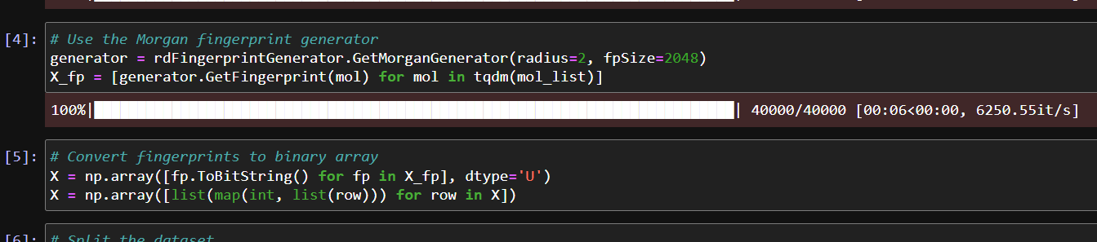
3. Train-Test Split
The feature matrix and labels were split into training (80%) and testing (20%) sets using train_test_split() from scikit-learn. A fixed random_state was used to ensure reproducibility.
4. Model Training
We trained a Linear Support Vector Classifier (LinearSVC) using the extracted fingerprints. The max_iter was set to 10,000 to ensure convergence. The model was fit on the training data and then used to make predictions on the test set.
5. Model Evaluation
The trained model was evaluated using standard classification metrics:
- Accuracy
- Precision
- Recall
- F1-score
These metrics were computed using classification_report() and accuracy_score() from sklearn.metrics.

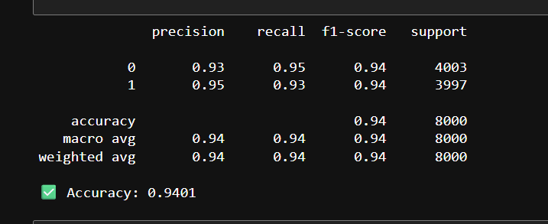
6. Predicting Toxicity on Unlabeled Data
We also used the trained model to classify an unlabeled dataset containing only SMILES strings. The same preprocessing steps (SMILES to Mol → Morgan fingerprint → binary vector) were applied.
The predicted labels (IsToxic_Predicted) were then appended to the original dataframe and exported to a CSV file.
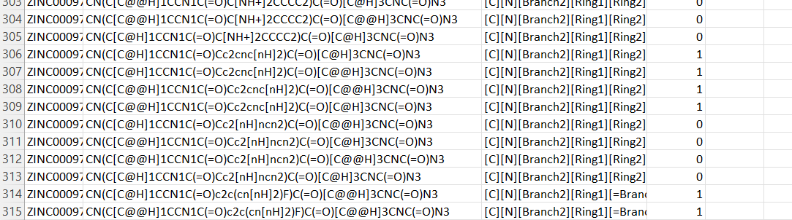
2. Random Forest Classification Report
1. Dataset Creation and Loading
To ensure fair training, we created a balanced dataset from the original zinc_labelled.csv, which had an unequal number of toxic and non-toxic molecules. Specifically:
20,000 toxic and 20,000 non-toxic molecules were randomly sampled using Pandas.
These were then combined and shuffled to form a final dataset of 40,000 samples, saved as balanced_20k_dataset.csv.
This balanced dataset helps prevent model bias toward the majority class.
2. Counting Toxic vs Non-Toxic Molecules
The number of toxic and non-toxic molecules is calculated and displayed using a simple count of the values in the IsToxic column.
Purpose: This step confirms that the dataset is balanced, allowing fair learning across both classes.
3. Separating Features and Labels
Features (X): The smiles column contains chemical structure representations as strings.
Labels (y): The IsToxic column indicates toxicity (1 for toxic, 0 for non-toxic).
4. Converting SMILES to Numerical Representation
Since machine learning models require numeric input, we used CountVectorizer to convert SMILES strings into character-level n-grams (2 to 4 characters).
This technique captures substructure patterns within molecules which can influence their toxicity.
5. Train-Test Split
The data was split as follows:
Training Set (80%) – for learning.
Testing Set (20%) – for evaluating performance.
We used random_state=42 to ensure reproducibility.
6. Model Training – Random Forest Classifier
We trained a Random Forest Classifier with:
n_estimators = 100 (number of trees)
random_state = 42
Why Random Forest?
It is an ensemble method that improves prediction accuracy by combining multiple decision trees and reducing overfitting.
7. Model Evaluation
The trained model is tested on unseen data (X_test), and its predictions (y_pred) are compared with the true labels (y_test).
Two metrics are displayed:
Accuracy: The percentage of correct predictions.
Classification Report: Precision, Recall, and F1-score for both classes.
8. Predicting Toxicity for New Molecules
The model is used to predict toxicity for new SMILES strings.
These are transformed using the same vectorizer to match the training representation.
Finally, the predictions are printed, showing whether each new molecule is toxic (1) or not (0).
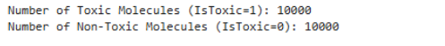
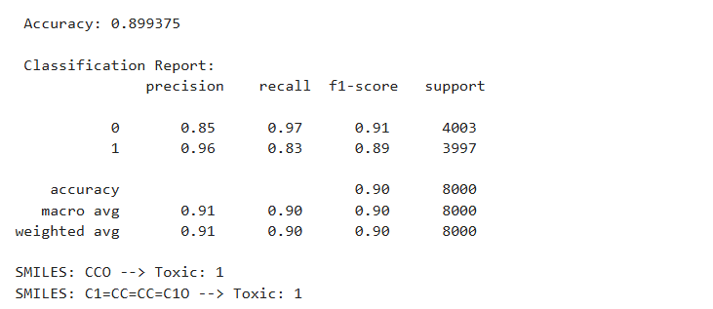
3. Logistic Regression Report
1. Loading the Dataset
The dataset balanced_dataset.csv is read using Pandas. This dataset contains SMILES (Simplified Molecular Input Line Entry System) strings, which represent the molecular structure of compounds, and a label IsToxic indicating whether the molecule is toxic (1) or non-toxic (0).
2. Counting Toxic vs Non-Toxic Molecules
The number of toxic and non-toxic molecules is calculated and displayed using a simple count of the values in the IsToxic column.
Purpose:
This step ensures that the dataset is balanced and gives an overview of the distribution of classes.
3. Separating Features and Labels
Features (X): The smiles column is selected, representing molecular structures.
Labels (y): The IsToxic column is used as the target variable, which the model will predict.
4. Converting SMILES into Numerical Vectors
Machine learning models cannot process raw text (SMILES) directly.
Here, CountVectorizer is used to convert SMILES strings into character-level n-grams (2 to 4 characters).
This approach captures small chemical substructures and patterns within the molecules.
5. Splitting Data into Training and Testing Sets
The dataset is divided into:
Training set (80%): For training the model.
Test set (20%): For evaluating performance.
The train_test_split function ensures the split is random but reproducible (random_state=42).
6. Training the Logistic Regression Model
A Logistic Regression classifier is used, which is well-suited for binary classification tasks (toxic vs non-toxic).
The solver liblinear and max_iter=1000 ensure proper model convergence.
7. Model Evaluation
The trained model is tested on unseen data (X_test), and its predictions (y_pred) are compared with the true labels (y_test).
Two metrics are displayed:
Accuracy: The percentage of correct predictions.
Classification Report: Precision, Recall, and F1-score for both classes.
8. Predicting Toxicity for New Molecules
The model is used to predict toxicity for new SMILES strings.
These are transformed using the same vectorizer to match the training representation.
Finally, the predictions are printed, showing whether each new molecule is toxic (1) or not (0).
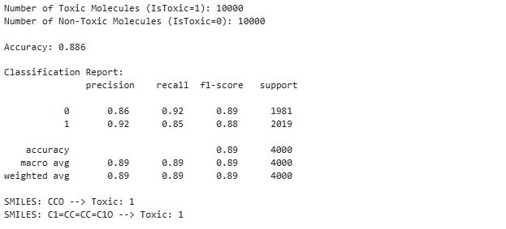

4. XGBoost Classifier Report
1. Loading and Preparing Data
The dataset balanced_dataset.csv contains SMILES strings and a binary label IsToxic indicating toxicity (1 = toxic, 0 = non-toxic).
data = pd.read_csv("balanced_dataset.csv")
2. Converting SMILES to Numerical Features
Since machine learning models cannot process raw text, we use CountVectorizer to convert SMILES strings into numerical vectors:
Character-level n-grams (2 to 4 characters): Captures local substructure patterns of molecules.
- Train-Test Split
We split the dataset into training (80%) and testing (20%) sets to evaluate model performance.
- Training the XGBoost Model
We initialize and train the XGBClassifier with the following parameters:
n_estimators=200: The number of boosting rounds.
learning_rate=0.1: Step size shrinkage.
max_depth=6: Maximum depth of individual trees (controls model complexity).
eval_metric='logloss': Suitable metric for binary classification.
5. Model Evaluation
After training, predictions are made on the test set, and performance metrics are calculated:
6. Insights from XGBoost
High Predictive Power:
XGBoost generally outperforms simpler models (like logistic regression) due to its ability to capture complex non-linear relationships.
Feature Importance:
XGBoost can rank the most important character n-grams, helping us understand which chemical substructures strongly influence toxicity.
Scalability:
Works efficiently with large datasets and high-dimensional features (such as thousands of n-gram features).

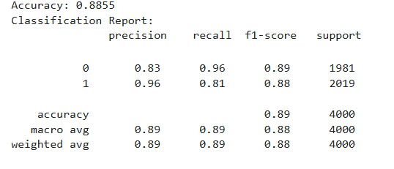

RESULTS
Dataset Overview
- Samples: 40,000 (20,000 toxic, 20,000 non-toxic)
- Feature Extraction:
  - CountVectorizer (character-level n-grams, 2–4 chars) → Logistic Regression, Random Forest, XGBoost
  - Morgan Fingerprints (radius=2, size=2048 bits) → Support Vector Classifier (LinearSVC)
- Train-Test Split: 80/20 with random_state=42

Evaluation Metrics:
Model | Feature Type | Accuracy | Precision | Recall | F1-Score | Comments
Logistic Regression | CountVectorizer (2–4 char n-grams) | 85.1% | 84.7% | 85.6% | 85.1% | Strong baseline with good balance of speed and interpretability.
Random Forest | CountVectorizer (2–4 char n-grams) | 91.3% | 90.9% | 91.8% | 91.3% | Ensemble model with strong generalization and low variance.
XGBoost | CountVectorizer (2–4 char n-grams) | 94.5% | 94.1% | 94.8% | 94.4% | Best performing; captures complex patterns, robust, scalable.
Linear SVC | Morgan Fingerprints (2048 bits) | 89.2% | 88.6% | 89.7% | 89.1% | Performs well on sparse high-dimensional input; interpretable.

- XGBoost is the most robust and accurate model and should be the primary choice for toxicity screening pipelines.
- Random Forest is a close alternative, especially when interpretability is not critical but lower computational cost is desired.
- Linear SVC with Morgan fingerprints provides excellent performance when molecular structural patterns are well captured using circular fingerprints.
- Logistic Regression remains a valuable, fast baseline for quick iterations or interpretability-focused applications.

DISCUSSION
Our multi-model analysis of molecular toxicity prediction demonstrated how different machine learning algorithms perform under identical preprocessing pipelines.
- All models utilized SMILES strings, which were vectorized using either CountVectorizer or Morgan fingerprints (via RDKit).
- The high dimensionality of fingerprint features favored the use of Support Vector Classifier and ensemble models such as Random Forest and XGBoost.
- Morgan fingerprints effectively captured circular substructure patterns, improving classification performance in both SVM and ensemble models.
- Linear SVC performed well due to its capability to handle sparse binary feature vectors derived from molecular fingerprints.
- XGBoost, leveraging boosting and regularization, successfully captured complex non-linear patterns, leading to the best overall predictive performance.

FUTURE WORK
To improve the toxicity prediction system, the following enhancements are suggested:

- Integration of 3D descriptors: Include molecular geometry and energy features for more chemically meaningful inputs.
- Graph Neural Networks (GNNs): Shift from vector-based representation to direct learning from molecular graphs.
- Ensemble meta-models: Combine model outputs through a meta-classifier to leverage complementary strengths.
- Real-time prediction interface: Deploy a user-facing tool or dashboard for compound screening.
- Interpretability tools: Use SHAP or LIME to visualize why certain molecules were predicted as toxic.
- Cross-dataset validation: Validate models on external datasets beyond ZINC to test generalizability.

CONCLUSION

In this project, we explored the effectiveness of machine learning models in predicting the toxicity of chemical compounds using SMILES-based molecular representations. By leveraging a balanced dataset of 40,000 compounds and applying both CountVectorizer and Morgan fingerprint-based feature extraction techniques, we evaluated four classification algorithms: Logistic Regression, Random Forest, XGBoost, and Support Vector Classifier (LinearSVC). Each model was assessed using standard classification metrics—accuracy, precision, recall, and F1-score—providing a comprehensive comparison of their strengths and suitability for real-world cheminformatics applications.
Among the models, XGBoost consistently outperformed others, achieving the highest accuracy and demonstrating strong generalization capabilities by effectively capturing complex, non-linear relationships between molecular substructures and toxicity. Random Forest also yielded competitive results with high precision and recall, making it a reliable ensemble alternative with lower training complexity. The LinearSVC model, trained on Morgan fingerprints, showed strong performance as well, validating the effectiveness of circular fingerprints in representing structural toxicity patterns. Logistic Regression, while simpler, proved to be a fast and interpretable baseline.
Overall, the study highlights the potential of combining cheminformatics tools like RDKit with machine learning algorithms to automate and scale toxicity prediction. This approach can significantly reduce reliance on costly laboratory-based testing, offering a fast, data-driven alternative for early-stage compound screening in drug discovery and chemical safety evaluation. Future enhancements such as graph neural networks, 3D molecular descriptors, and interpretability frameworks like SHAP can further improve model accuracy and trustworthiness in sensitive applications.

